**iSphere 4.1 Test Protocol**

|  |  |  |
| --- | --- | --- |
| **Komponente** | **Default System Profile** | **Test:Profile** |
| Binding Directory Editor |  |  |
| * Open editor | OK | OK |
| * Change Entry | OK | OK |
| Data Area Editor |  |  |
| * Open editor | OK | OK |
| * Change Area | OK | OK |
| Data Area Monitor |  |  |
| * Open | OK | OK |
| * Auto-Refresh | OK | OK |
| * Pin-View | OK | OK |
| Data Queue Monitor |  |  |
| * Open | OK | OK |
| * Auto-Refresh | OK | OK |
| * Send Message | OK | OK |
| * Pin-View | OK | OK |
| User Space Editor |  |  |
| * Open | OK | OK |
| * Change Space | OK | OK |
| User Space Monitor |  |  |
| * Open | OK | OK |
| * Auto-Refresh | OK | OK |
| * Pin-View | OK | OK |
| Source File Search |  |  |
| * Selected Member | OK | OK |
| * Selected Filter | OK | OK |
| * Selected Source Files | OK | OK |
| * Open Member | OK | OK |
| * Open Statement | OK | OK |
| * Compare Members | OK | OK |
| * Create Filter | OK | OK |
| * Export to Excel | OK | OK |
| Message File Search |  |  |
| * Selected Message Files | OK | OK |
| * Selected Filter | OK | OK |
| * Open Message File | OK | OK |
| * Edit Message Description | OK | OK |
| * Export to Excel | OK | OK |
| Retrieve Binder Source |  |  |
| * To Clipboard | OK | OK |
| * To Member | OK | OK |
| Spooled File Subsystem |  |  |
| * En on Double Click | OK | OK |
| * Hold/Release | OK | OK |
| * Delete | OK | OK |
| * Open as… | OK | OK |
| * Save as… | OK | OK |
| Work With Spooled Files |  |  |
| * Opened from Filter | OK | OK |
| * Pin-View | OK | OK |
| * Rename Filter | OK | OK |
| * Rename Connection | OK | OK |
| * Auto-Refresh | OK | OK |
| * Opened from debug stack | OK | OK |
| * Opend from job of RSE view | OK | OK |
| Job Log Explorer |  |  |
| * Opened From Spooled File RSE View | OK | OK |
| * Opened from WrkSplF View | OK | OK |
| * Opened from active job | OK | OK |
| * Opened from debug stack | OK | OK |
| Journal Explorer |  |  |
| * Open from journal | OK | OK |
| * Opened from file | OK | OK |
| * Opened from output file | OK | OK |
| Job Trace Explorer |  |  |
| * Open | OK | OK |
| CMOne Worklist |  |  |
| * Binding Directory Editot (open/browse) | OK |  |
| * Message File Editor (open/browse) | OK |  |
| * Data Area Editor (open/browse) | OK |  |
| * User Space Editor (open/browse) | OK |  |
| * Source File Compare | OK |  |
| * Source File Search | OK |  |
| CMOne Source File Search |  |  |
| * Open Editor From Statement | OK |  |
| * Open Editor From Member | OK |  |
| * Filter Search Result | OK |  |
| CMOne Spooled Files |  |  |
| * Open View From Filter | OK |  |
| * Load SplF Into Editor | OK |  |

TODO:

* Fix "widget is disposed exception" in data area, data queue, user space monitors, when auto-refresh is enabled and the view is closed.
* ~~Fix NullPointerException in TN5250JSubSystem, when loading the RSE session in method getRSESessions(). Problem: A colon (from system profile name) is not allowed in a Windows path name. In RDP 8.0 colons were not allowed for System Profile Names.~~**~~Fixed with rev. 7753~~**
* Create support case to get the following exception fixed:  
  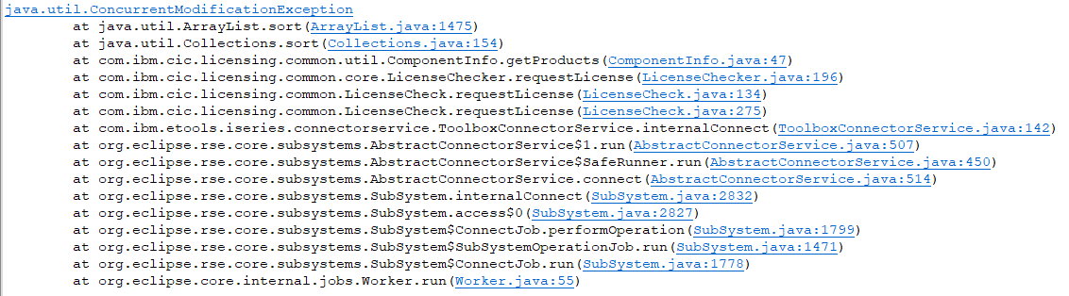  
    
  The exception happens, when loading multiple pinned monitor views.  
  See: DataSpaceMonitorView, connection.getObject(remoteObject.getLibrary(), remoteObject.getName(), remoteObject.getObjectType(), null);  
  Return "null" on error.
* ~~Create support case, SEP cannot be set for connection "Test:Profile", when connection "iSphere" is offline?~~**~~Cannot be reproduced.~~**
* Change CMOne to call TN5250JRSEPlugin. getRSESessionDirectory(String rseProfile, String rseConnection) instead of getRSESessionDirectory(String rseProfile, String rseConnection). getRSESessionDirectory(String connection).
* Fix that CMOne cannot use RSE connections with a system profile name containing a colon.
* Change CMOne to pass the connection name as "systemPrifileName:connectionName".